**Managerial Economics and Financial Accounting**

**Unit 3**

**COST ANALYSIS**

Profit is the ultimate aim of any business and the long-run prosperity of a firm depends upon its ability to earn sustained profits. Profits are the difference between selling price and cost of production. In general the selling price is not within the control of a firm but many costs are under its control. The firm should therefore aim at controlling and minimizing cost. Since every business decision involves cost consideration, it is necessary to understand the meaning of various concepts for clear business thinking and application of right kind of costs.

**COST CONCEPTS:**

A managerial economist must have a clear understanding of the different cost concepts for clear business thinking and proper application. The several alternative bases of classifying cost and the relevance of each for different kinds of problems are to be studied. The various relevant concepts of cost are:

**1. Opportunity costs and outlay costs:**

Out lay cost also known as actual costs obsolete costs are those expends which are actually incurred by the firm these are the payments made for labour, material, plant, building, machinery traveling, transporting etc., These are all those expense item appearing in the books of account, hence based on accounting cost concept.

On the other hand opportunity cost implies the earnings foregone on the next best alternative, has the present option is undertaken. This cost is often measured by assessing the alternative, which has to be scarified if the particular line is followed.

The opportunity cost concept is made use for long-run decisions. This concept is very important in capital expenditure budgeting. This concept is very important in capital expenditure budgeting. The concept is also useful for taking short-run decisions opportunity cost is the cost concept to use when the supply of inputs is strictly limited and when there is an alternative. If there is no alternative, Opportunity cost is zero. The opportunity cost of any action is therefore measured by the value of the most favorable alternative course, which had to be foregoing if that action is taken.

**2. Explicit and implicit costs:**

Explicit costs are those expenses that involve cash payments. These are the actual or business costs that appear in the books of accounts. These costs include payment of wages and salaries, payment for raw-materials, interest on borrowed capital funds, rent on hired land, Taxes paid etc.

Implicit costs are the costs of the factor units that are owned by the employer himself. These costs are not actually incurred but would have been incurred in the absence of employment of self – owned factors. The two normal implicit costs are depreciation, interest on capital etc. A decision maker must consider implicit costs too to find out appropriate profitability of alternatives.

3. **Short – run and long – run costs:**

Short-run is a period during which the physical capacity of the firm remains fixed. Any increase in output during this period is possible only by using the existing physical capacity more extensively. So short run cost is that which varies with output when the plant and capital equipment in constant.

Long run costs are those, which vary with output when all inputs are variable including plant and capital equipment. Long-run cost analysis helps to take investment decisions.

4.  **Out-of pocket and books costs:**

Out-of pocket costs also known as explicit costs are those costs that involve current cash payment. Book costs also called implicit costs do not require current cash payments. Depreciation, unpaid interest, salary of the owner is examples of back costs.

But the book costs are taken into account in determining the level dividend payable during a period. Both book costs and out-of-pocket costs are considered for all decisions. Book cost is the cost of self-owned factors of production.

**5. Fixed and variable costs:**

Fixed cost is that cost which remains constant for a certain level to output. It is not affected by the changes in the volume of production. But fixed cost per unit decrease, when the production is increased. Fixed cost includes salaries, Rent, Administrative expenses depreciations etc.

Variable is that which varies directly with the variation is output. An increase in total output results in an increase in total variable costs and decrease in total output results in a proportionate decline in the total variables costs. The variable cost per unit will be constant. Ex: Raw materials, labour, direct expenses, etc.

**6. Past and Future costs:**

Past costs also called historical costs are the actual cost incurred and recorded in the book of account these costs are useful only for valuation and not for decision making.

Future costs are costs that are expected to be incurred in the futures. They are not actual costs. They are the costs forecasted or estimated with rational methods. Future cost estimate is useful for decision making because decision are meant for future.

**7. Avoidable and unavoidable costs:**

Avoidable costs are the costs, which can be reduced if the business activities of a concern are curtailed. For example, if some workers can be retrenched with a drop in a product – line, or volume or production the wages of the retrenched workers are escapable costs.

The unavoidable costs are otherwise called sunk costs. There will not be any reduction in this cost even if reduction in business activity is made. For example cost of the ideal machine capacity is unavoidable cost.

**8. Controllable and uncontrollable costs:**

Controllable costs are ones, which can be regulated by the executive who is in change of it. The concept of controllability of cost varies with levels of management. Direct expenses like material, labour etc. are controllable costs.

Some costs are not directly identifiable with a process of product. They are appointed to various processes or products in some proportion. This cost varies with the variation in the basis of allocation and is independent of the actions of the executive of that department. These apportioned costs are called uncontrollable costs.

**9. Incremental and sunk costs:**

Incremental cost also known as different cost is the additional cost due to a change in the level or nature of business activity. The change may be caused by adding a new product, adding new machinery, replacing a machine by a better one etc.

Sunk costs are those which are not altered by any change – They are the costs incurred in the past. This cost is the result of past decision, and cannot be changed by future decisions. Investments in fixed assets are examples of sunk costs.

**10. Total, average and marginal costs:**

Total cost is the total cash payment made for the input needed for production. It may be explicit or implicit. It is the sum total of the fixed and variable costs. Average cost is the cost per unit of output. If is obtained by dividing the total cost (TC) by the total quantity produced (Q)

Average cost = TC/ Q

Marginal cost is the additional cost incurred to produce and additional unit of output or it is the cost of the marginal unit produced.

**11. Accounting and Economics costs:**

Accounting costs are the costs recorded for the purpose of preparing the balance sheet and profit and ton statements to meet the legal, financial and tax purpose of the company. The accounting concept is a historical concept and records what has happened in the post.

Economics concept considers future costs and future revenues, which help future planning, and choice, while the accountant describes what has happened, the economics aims at projecting what will happen.

**COST-OUTPUT RELATIONSHIP**

A proper understanding of the nature and behavior of costs is a must for regulation and control of cost of production. The cost of production depends on money forces and an understanding of the functional relationship of cost to various forces will help us to take various decisions. Output is an important factor, which influences the cost.

The cost-output relationship plays an important role in determining the optimum level of production. Knowledge of the cost-output relation helps the manager in cost control, profit prediction, pricing, promotion etc. The relation between cost and its determinants is technically described as the cost function.

C= f (S, O, P, T ….)

Where;

C= Cost (Unit or total cost)

S= Size of plant/scale of production

O= Output level

P= Prices of inputs or factors of production

T= Technology

f = Functional relationship

Considering the period the cost function can be classified as (a) short-run cost function and (b) long-run cost function. In economics theory, the short-run is defined as that period during which the physical capacity of the firm is fixed and the output can be increased only by using the existing capacity allows to bring changes in output by physical capacity of the firm.

**(a) Cost-Output Relation in the short-run:**

The cost concepts made use of in the cost behavior are total cost, Average cost, and marginal cost.

Total cost is the actual money spent to produce a particular quantity of output. Total cost is the summation of fixed and variable costs.

TC=TFC+TVC

Up to a certain level of production total fixed cost i.e., the cost of plant, building, equipment etc, remains fixed. But the total variable cost i.e., the cost of labour, raw materials etc., Vary with the variation in output. Average cost is the total cost per unit. It can be found out as follows.

AC= TC/ No. of units

The total of average fixed cost (TFC/Q) keep coming down as the production is increased and average variable cost (TVC/Q) will remain constant at any level of output.

Marginal cost is the addition to the total cost due to the production of an additional unit of product. It can be arrived at by dividing the change in total cost by the change in total output.

MC= TC (n) – TC (n-1)

In the short-run there will not be any change in total fixed cost. Hence change in total cost implies change in total variable cost only.

**Cost – output relations**

|  |  |  |  |  |  |  |  |
| --- | --- | --- | --- | --- | --- | --- | --- |
| Units of | Total | Total | Total cost | Average | Average | Average | Marginal |
| Output Q | fixed cost | variable | (TFC + | variable | fixed cost | cost | cost MC |
|  | TFC | cost TVC | TVC) TC | cost (TVC | (TFC / Q) | (TC/Q) |  |
|  |  |  |  | / Q) AVC | AFC | AC |  |
|  |  |  |  |  |  |  |  |
| 0 | 60 | - | 60 | - | - | - | - |
| 1 | 60 | 20 | 80 | 20 | 60 | 80 | 20 |
|  |  |  |  |  |  |  |  |
| 2 | 60 | 36 | 96 | 18 | 30 | 48 | 16 |
| 3 | 60 | 48 | 108 | 16 | 20 | 36 | 12 |
|  |  |  |  |  |  |  |  |
| 4 | 60 | 64 | 124 | 16 | 15 | 31 | 16 |
| 5 | 60 | 90 | 150 | 18 | 12 | 30 | 26 |
|  |  |  |  |  |  |  |  |
| 6 | 60 | 132 | 192 | 22 | 10 | 32 | 42 |

The above table represents the cost-output relation. The table is prepared on the basis of the law of diminishing marginal returns. The fixed cost Rs. 60 May include rent of factory building, interest on capital, salaries of permanently employed staff, insurance etc. The table shows that fixed cost is same at all levels of output but the average fixed cost, i.e., the fixed cost per unit, falls continuously as the output increases. The expenditure on the variable factors (TVC) is at different rate. If more and more units are produced with a given physical capacity the AVC will fall initially, as per the table declining up to 3rd unit, and being constant up to 4th unit and then rising. It implies that variable factors produce more efficiently near a firm’s optimum capacity than at any other levels of output.

And later rises. But the rise in AC is felt only after the start rising. In the table ‘AVC’ starts rising from the 5th unit onwards whereas the ‘AC’ starts rising from the 6th unit only so long as ‘AVC’ declines ‘AC’ also will decline. ‘AFC’ continues to fall with an increase in Output. When the rise in ‘AVC’ is more than the decline in ‘AFC’, the total cost again begin to rise. Thus there will be a stage where the ‘AVC’, the total cost again begin to rise thus there will be a stage where the ‘AVC’ may have started rising, yet the ‘AC’ is still declining because the rise in ‘AVC’ is less than the droop in ‘AFC’.

Thus the table shows an increasing returns or diminishing cost in the first stage and diminishing returns or diminishing cost in the second stage and followed by diminishing returns or increasing cost in the third stage.

The short-run cost-output relationship can be shown graphically as follows.

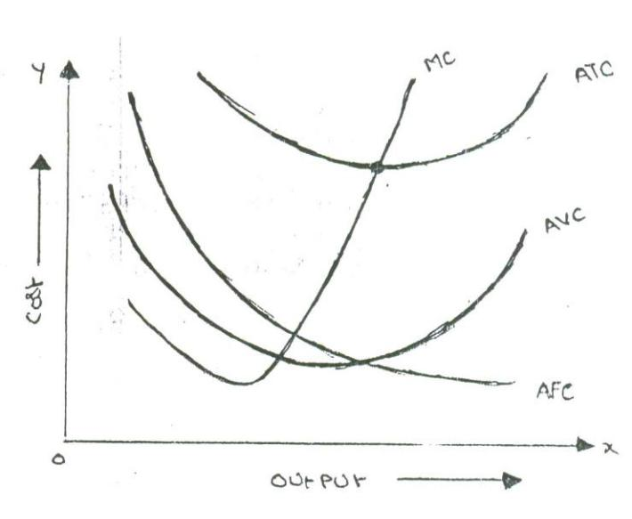

In the above graph the “AFC’ curve continues to fall as output rises an account of its spread over more and more units Output. But AVC curve (i.e. variable cost per unit) first falls and than rises due to the operation of the law of variable proportions. The behavior of “ATC’ curve depends upon the behavior of ‘AVC’ curve and ‘AFC’ curve. In the initial stage of production both ‘AVC’ and ‘AFC’ decline and hence ‘ATC’ also decline. But after a certain point ‘AVC’ starts rising. If the rise in variable cost is less than the decline in fixed cost, ATC will still continue to decline otherwise AC begins to rise. Thus the lower end of ‘ATC’ curve thus turns up and gives it a U-shape. That is why ‘ATC’ curve are U-shaped. The lowest point in ‘ATC’ curve indicates the least-cost combination of inputs. Where the total average cost is the minimum and where the “MC’ curve intersects ‘AC’ curve, It is not be the maximum output level rather it is the point where per unit cost of production will be at its lowest. The relationship between ‘AVC’, ‘AFC’ and ‘ATC’ can be summarized up as follows:

If both AFC and ‘AVC’ fall, ‘ATC’ will also fall.

When ‘AFC’ falls and ‘AVC’ rises

‘ATC’ will fall where the drop in ‘AFC’ is more than the raise in ‘AVC’.

‘ATC’ remains constant is the drop in ‘AFC’ = rise in ‘AVC’

‘ATC’ will rise where the drop in ‘AFC’ is less than the rise in ‘AVC’

**Break-Even-Point analysis-**

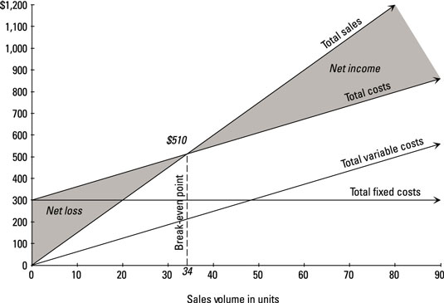

The point at which total of fixed and variable costs of a business becomes equal to its total revenue is known as **break-even point (BEP)**. At this point, a business neither earns any profit nor suffers any loss. Break-even point is therefore also known as no-profit, no-loss point or zero profit point. Calculation of break-even point is important for every business because it tells business owners and managers how much sales are needed to cover all fixed as well as variable expenses of the business or the sales volume after which the business will start generating profit. The computation of sales volume required to break-even is known as *break-even analysis*. The concept explained above can also be presented as follows:

1. **When there is a profit-**

Revenue > Variable cost + Fixed Cost

Or

Total Revenue > Total Cost

1. **At Break- even- point-**

Revenue = Variable cost + Fixed Cost

Or

Total Revenue = Total Cost

1. **When there is a loss-**

Revenue < Variable cost + Fixed Cost

Or

Total Revenue < Total Cost.